

**FOR MORE INFORMATION:**

Sarah Wynn Benton

BRAVE Public Relations

404.233.3993

[sbenton@emailbrave.com](mailto:sbenton@emailbrave.com)

**FOR IMMEDIATE RELEASE**

**Comedian Jo Koy Announced His Jo Koy: Just Being Koy Tour and Will   
be at the Fox Theatre on Saturday, Nov. 23***Tickets Go On-Sale This Thursday, May 9*

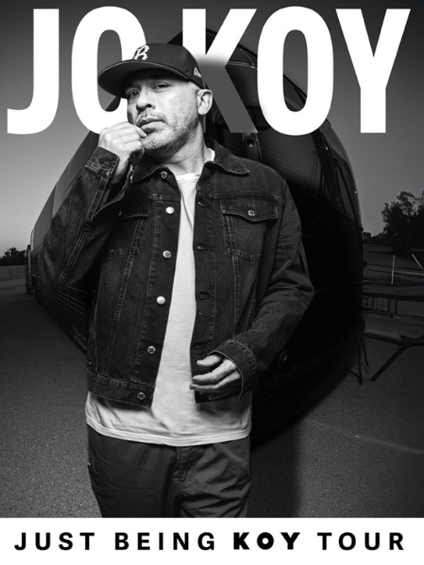

**ATLANTA (May 7, 2024)** – Today, Comedian Jo Koy announced his **ALL-NEW** JO KOY: JUST BEING KOY TOUR that will include a stop at the **Fox Theatre** on **Saturday, Nov. 23***.* The tour will kick off Sept. 6 at the Toyota Center in Houston and continue through 2025. Tickets go on-sale Thursday, May 9 at noon and will be available to purchase at [FoxTheatre.org](https://protect-us.mimecast.com/s/v0QXCOYoRKcNvKACmEBXS?domain=secure-web.cisco.com)

“I never take for granted that I get to live out my dream on the stage every week and this new tour is something special that I can’t what to share with everyone,” says Jo Koy.

As one of today’s premiere stand-up comedians, Jo Koy has come a long way from his modest beginnings performing in a Las Vegas coffee house. Jo’s uniquely relatable comedy pulls inspiration from his colorful family that has reached all kinds of people and has translated into sold-out arenas around the world.

In 2022, Koy kicked off his Funny Is Funny World Tour by selling-out the Climate Pledge Arena (over 14,000 tickets) in his hometown of Seattle and ended the tour with a sold-out show at Tacoma Dome (over 19,000 tickets). Today, he continues breaking sales records at some of the most prestigious venues around the world including Mall of Asia Arena (Manila, PH), The Forum (Los Angeles), Coca-Cola Arena (Dubai), ICC Theatre (Sydney, AU), Madison Square Garden (New York City), and American Airlines Arena (Dallas) to name a few. In 2017, Koy broke a record for the most tickets sold by a single artist at 23,000 tickets and 11 sold-out shows at The Neal S. Blaisdell Concert Hall in Honolulu. In response, the mayor’s office in Honolulu proclaimed Nov. 24 as “Jo Koy Day.”

Koy starred in the 2022 Universal Picture film“Easter Sunday*,*”set around a family gathering to celebrate Easter Sunday, the comedy is based on Jo Koy's life experiences and stand-up comedy. In 2023, Koy appeared in Disney’s “Haunted Mansion”and voiced characters in Netflix’s animated films, “Monkey King and Leo.” In 2024, he was most recently heard voicing the character Monkey King in the Paramount+ film, “The Tiger’s Apprentice.”

In 2023, it was announced that he inked a two-special deal with Netflix. The first special was filmed this past November at The Kings Theatre in Brooklyn and will release in the summer of 2024. He’s had 4 highly rated specials including his latest Netflix stand-up special, “Live From The Los Angeles Forum,” which premiered globally on September 2022. The special was follow up to his 2019 Netflix special, “Comin’ In Hot.”Overall,Koy has had six highly rated and successful stand-up specials on Comedy Central and Netflix. In June 2020, the comedian released his first variety special, “Jo Koy: In His Elements”on Netflix in which Koy brings the laughs and beats to Manila, spotlighting local culture in a one-of-a-kind show featuring Filipino-American comedians, DJs and B-boys.

In 2021, Koy released his first autobiography, “Mixed Plate: Chronicles of an All-American Combo”with Harper Collins Publishers to raved reviews. In this funny and moving memoir, Koy uncovers the stories behind his stand-up: the conflict, the drama and the laughter as he struggles to find his place in the entertainment industry, his home and around the world.

In 2019, Jo Koy reached #1 on the Billboard Charts for his stand-up comedy album, “Live from Seattle,” and in 2018, he was given the prestigious “Stand-Up Comedian Of The Year” award at the Just For Laughs Comedy Festival in Montreal.

For more info on his comedy, book and tour dates, please visit: [Jokoy.com](https://jokoy.com/).

###

**About the Fox Theatre**  
The Fox Theatre is one of Atlanta's premier venues for live entertainment, welcoming more than 150 performances a year in its 4,665-seat theatre. From concerts to ballets, comedy, and movies, the historic venue attracts more than 500,000 visitors annually. The theatre hosts over 100 annual private events like wedding receptions, trade shows, corporate meetings, and association functions in two fabulous ballrooms. The Fox’s premium Marquee Club, presented by Lexus, is a 10,000 sq. ft, three-story luxury bar accessible to all Club Level ticket holders or annual members of the Fox Theatre. As a 501(c)(3) nonprofit arts organization, the Fox Theatre stands today as a fiercely protected landmark and a nationally acclaimed theatre. The Fox Theatre proudly acknowledges its partners' generous support: Coca-Cola, Georgia Natural Gas, Georgian Terrace Hotel & Livingston Restaurant, Humana, Lexus, Northside Hospital, and Regions Bank. Tickets for all events are available at [FoxTheatre.org](https://protect-us.mimecast.com/s/v0QXCOYoRKcNvKACmEBXS?domain=secure-web.cisco.com), or toll-free at 855-285-8499. Stay connected by following the Fox Theatre on social via @theFoxTheatre on [Instagram](https://protect-us.mimecast.com/s/SE2wCPNp8Li03x4HxEXzY?domain=secure-web.cisco.com), [Twitter](https://protect-us.mimecast.com/s/6oQPCQWqRMHXoW6i7XoPc?domain=secure-web.cisco.com), [and Facebook](https://protect-us.mimecast.com/s/kDgUCR6r7NtG5LrIZrWlF?domain=secure-web.cisco.com).

Notable accolades include 2023 Billboard Magazine #2 Highest Grossing Theatre Worldwide (5,000 seats or less); 2023 VenuesNow Magazine #2 Year-End Top Stops (2,001-5,000 seats); 2022 IEBA Theatre of the Year; 2021 Billboard Magazine #1 Highest Grossing Theatre Worldwide (5,000 seats or less); 2021 Pollstar Magazine #2 Theatre Worldwide in Ticket Sales and 2021 VenuesNow Magazine #2 Year-End Top Stops (2,001-5,000 seats). Additionally, in 2019, the Fox Theatre was honored with the VenuesNow #1 Top Stop of the Decade Award for Tickets Sold, further cementing its reputation as a premier entertainment venue.